**Organizational Management System**

* **Core Features:**

1. **Comprehensive User Management**: The system centralizes user information, combining traditional user profile data with detailed employment information into a single USER entity. This integration includes personal details, role assignments (USERROLE), department affiliations (DEPARTMENT), and employment specifics such as salary and tenure. This unified approach streamlines user administration and enhances data coherence.
2. **Role-Based Access and Responsibilities**: Each user is assigned a specific role (USERROLE), which defines their access levels and responsibilities within the system. This feature allows for a clear delineation of duties and privileges, from administrative functions to regular employee tasks.
3. **Departmental Structure and Project Oversight**: Departments (DEPARTMENT) within the organization are clearly defined, with each department potentially overseeing multiple projects (PROJECT). This structure facilitates effective management and coordination of various organizational initiatives.
4. **Dynamic Project Management**: The system supports dynamic project management, allowing projects (PROJECT) to be associated with both departments and individual users. This dual association aids in efficient task allocation and progress tracking, ensuring that projects are managed effectively within the organizational framework.
5. **User-Centric Feedback Mechanism**: Users can provide feedback (FEEDBACK) related to different aspects of the system, including projects and services. This mechanism enables the organization to gather valuable insights and foster a culture of continuous improvement.
6. **Resource Utilization and Tracking**: The system includes a feature for managing various units or resources (UNIT), directly linked to users. This approach allows for detailed tracking and utilization of resources, aligning them with individual user activities and responsibilities.
7. **Flexible Request Processing**: A notable feature is the handling of different types of requests (REQUEST), such as vacation (VACATION) and off-site work (OSW). Users have the capability to both submit and approve these requests, facilitating a flexible and responsive system for managing personal and professional needs.
8. **Circular Approval Dynamics**: The system introduces a circular relationship in request processing, where users can be both applicants and approvers of requests (REQUEST), depending on their roles and the nature of the request. This design promotes a balanced and efficient approach to request management

* **Intended Users:**
* **Administrators:** Oversee the entire system, manage content, user roles, and high-level organizational structure.
* **HR Personnel:** Handle employee details, departmental assignments, and related HR tasks.
* **Project Managers/Leads:** Manage projects, coordinate with departments, customers, and partner companies.
* **Employees:** Access their personal and employment details, participate in projects, and utilize organizational resources.
* **Overall Goal:**

The primary goal of this system is to offer a comprehensive and integrated solution for managing organizational operations. It combines user management, project oversight, resource allocation, and feedback mechanisms into a unified platform. This system streamlines processes, enhances efficiency, and supports dynamic user roles, making it ideal for modern organizational needs. Its design focuses on flexibility, user-centric features, and efficient management of resources and personnel.

**Relationships:**

1. **USER and USERROLE: One-to-Many. Each user has one role, but each role can be associated with multiple users. This relationship indicates the assignment of roles to users within the system.**
2. **USERROLE and PROJECT: One-to-Many. Each user role can manage or be associated with multiple projects. This suggests that specific roles have responsibilities or involvement in various projects.**
3. **USER and DEPARTMENT: One-to-Many. Each user works in one department, but a department can have multiple users. This relationship reflects the organizational structure where users are grouped into departments.**
4. **DEPARTMENT and PROJECT: One-to-Many. Each department can oversee multiple projects. This indicates that departments are responsible for the management or execution of various projects.**
5. **USER and PROJECT: One-to-Many. A user can work on multiple projects. This relationship allows users to be involved in more than one project at a time.**
6. **USER and FEEDBACK: One-to-Many. A user can provide feedback on multiple occasions. This relationship enables users to contribute feedback on various aspects or projects within the system.**
7. **USER and REQUEST: One-to-Many (Circular). A user can apply for and also approve requests. This circular relationship indicates that users have the capability to both submit requests (like vacation or OSW) and have the authority to approve them, depending on their role.**
8. **REQUEST and VACATION: One-to-One. Each request of type 'Vacation' has a start and end date. This relationship specifies the structure of vacation requests.**
9. **REQUEST and OSW: One-to-One. Each request of type 'OSW' (Off-Site Work) has a reason. This relationship defines the structure of OSW requests.**
10. **USER and UNIT: One-to-Many. A user can use multiple units. This relationship suggests that users have access to or are responsible for various units or resources within the organization.**

**Roles:**

1. **Administrator**:
   * **Add/Update/Delete the main page contents**: Manages the content on the main page of the website.
   * **View all employees’ profiles**: Accesses and reviews the profiles of all employees in the organization.
   * **Add/Edit/Delete employees**: Manages employee records in the system.
   * **Add/Edit/Delete Departments**: Manages information about different departments.
   * **Manage User Roles**: Assigns and modifies roles for users in the system.
   * **Oversee Project Assignments**: Manages which projects are assigned to which departments or employees.
2. **HR (Human Resources)**:
   * **View all employees profiles**: Accesses and reviews the profiles of all employees.
   * **Add/Edit/Delete salaries, start date, end date, etc.**: Manages employment details such as salaries and employment dates.
   * **Add/Edit behavior notes for employees**: Manages notes related to employee behavior and performance.
   * **Manage Employee Details**: Updates and maintains additional personal details of employees.
3. **Lead**:
   * **View his/her profile and employees under him/her**: Accesses their own profile and those of direct reports.
   * **Manage Project Tasks**: Assigns and oversees tasks within projects for their team.
   * **Collaborate with Departments**: Coordinates with different departments for project-related activities.
4. **Employee**:
   * **View his full profile (basic details/department/salary, etc.)**: Accesses their complete profile including personal, departmental, and salary information.
   * **Update Personal Details**: Can update their own basic personal details.
   * **View Assigned Projects**: Sees projects they are working on and their details.
   * **Provide Project Feedback**: Submits feedback related to projects they are involved in.

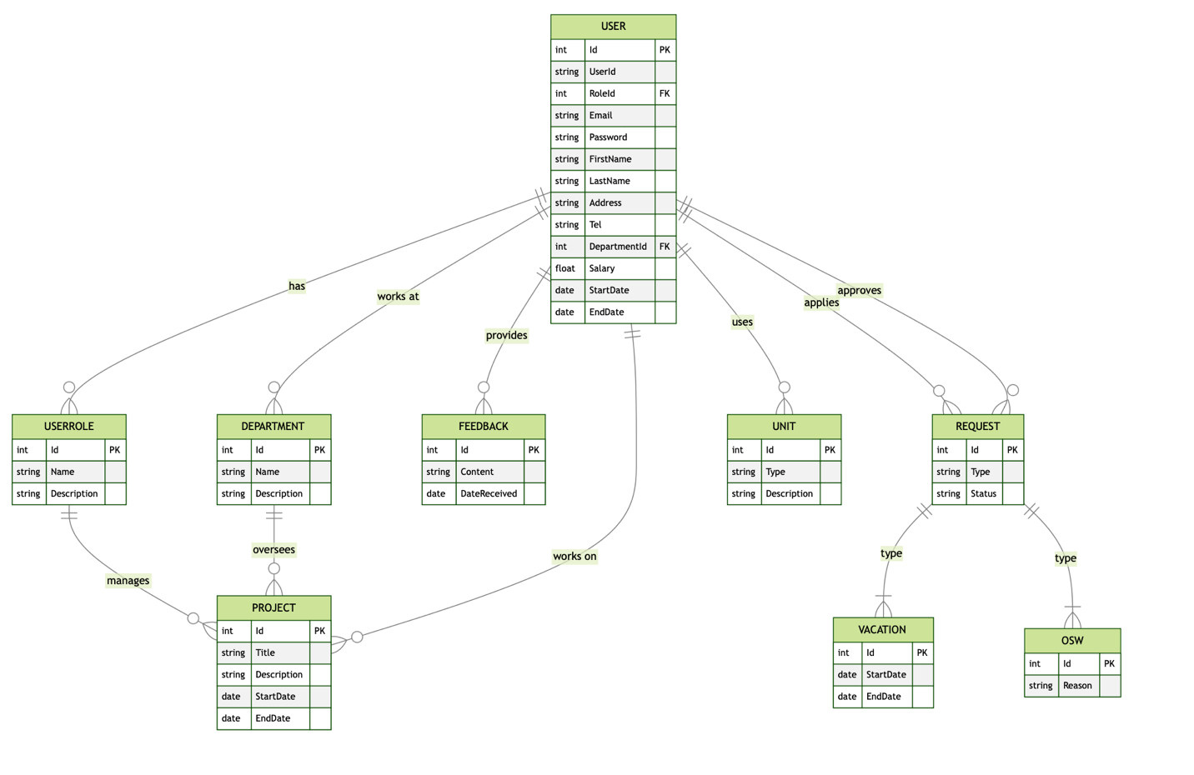

Figure 1: ERD